Control Engineering

Handout – Online Laboratory 2

Name: *Colda Andreea Ariana*

Group: *30332*

3. PROBLEMS  
For the process described by Hf (s) = $\frac{1}{2s+1}$ highlight the performance indicators in steady-state and transient state in both time domain and frequency domain, using Matlab. Compare and explain the results for the three different type of controller.

a) HR (s) = 2

*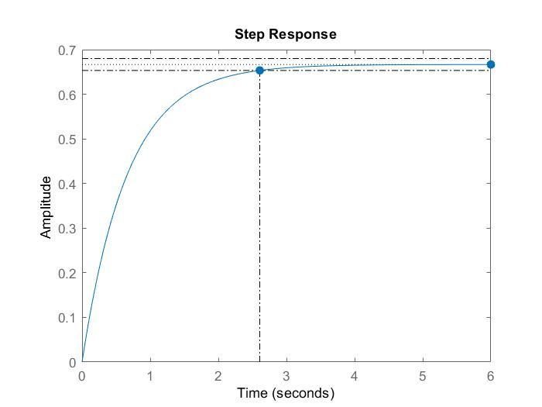*

*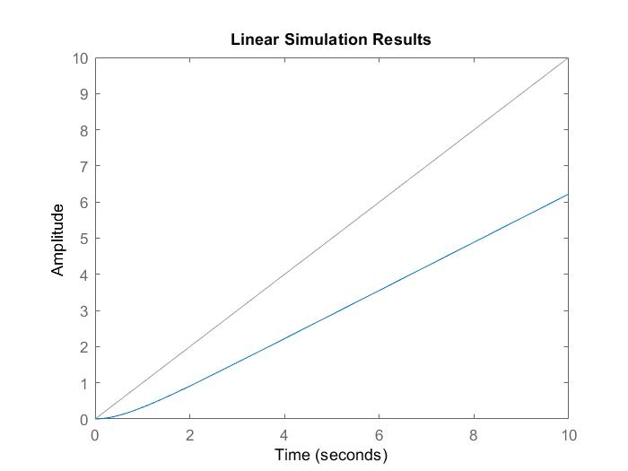*

*Time domain: $ε_{stp} =$ 1/3 $ε_{stv} =$ infinity $ε_{sta} =$ infinity*

$c_{p}=$*2 $c_{v}=$ 0 $c_{a}=$ 0*

$t_{s} =$ 2.67 s $σ =$ 0 %

b) HR (s) = $\frac{2}{s}$

 

*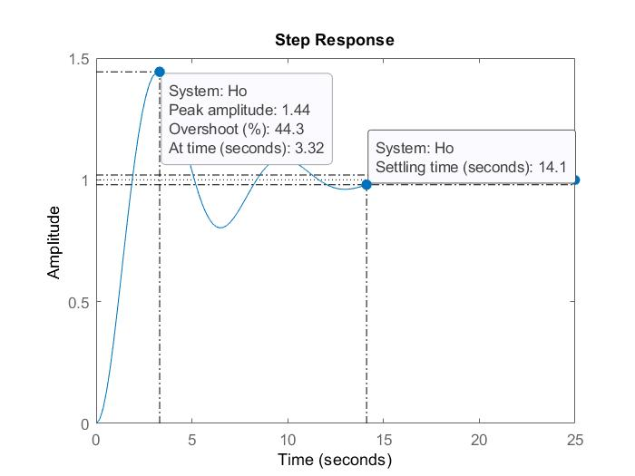*

*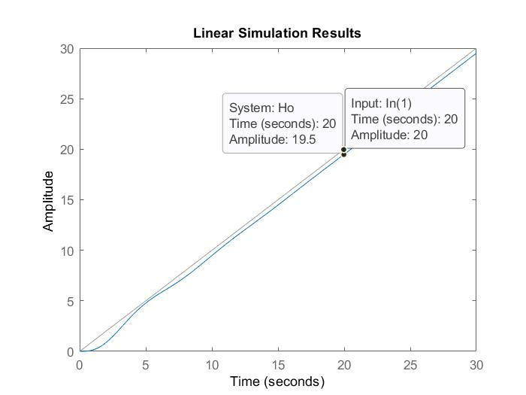*

*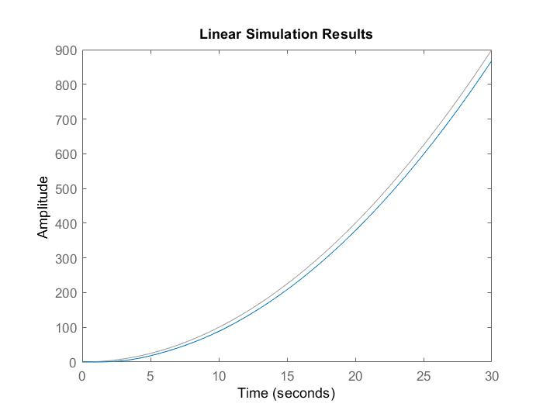*

*Time domain: $ε_{stp} =$ 0 $ε_{stv} =$ 0.5 $ε_{sta} =$ infinity*

$c_{p}=$*infinity $c_{v}=$ 2 $c_{a}=0$*

$t_{s} =$ 14.1 $σ = 44.3$%

c) HR (s) = $\frac{2}{s^{2}}$

 

*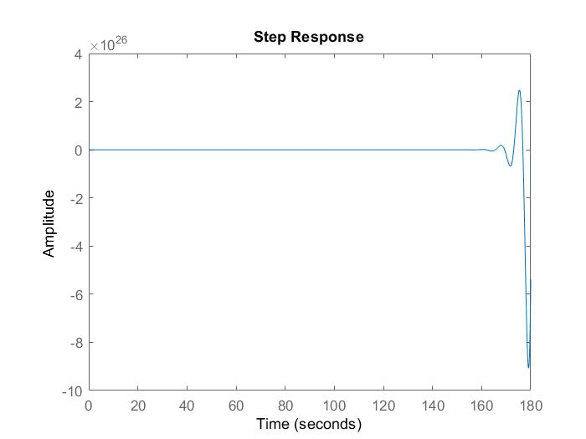*

*Unstable system*

*Time domain: $ε_{stp} =$ $ε_{stv} =$ $ε_{sta} =$*

$c_{p}=$ $c_{v}=$ $c_{a}=$

$t_{s} =$ $σ =$

All done? Great job 🍾🎉🎊! Upload this document along with your Matlab/Simulink files in the Assignments section of the Control Engineering I group in Teams (pay attention to select the correct Assignment!).